**LAB 8:  
SUBMITTED BY: NOOR-UL-AIN SAGHEER (BCS223020)**

**PRACTICE TASK 1:  
CODE:**

#include<iostream>

using namespace std;

class Car

{

protected:

string car_name;

int speed;

public:

Car()

{

car_name = "";

speed = 0;

}

Car(string name, int s)

{

car_name = name;

speed = s;

}

void set_name(string name)

{

car_name = name;

}

void set_speed(int s)

{

speed = s;

}

string get_name()

{

return car_name;

}

int get_speed()

{

return speed;

}

void display()

{

cout << " Call to base class : " << endl;

cout << " Car name: " << car_name << endl;

cout << " Car speed: " << speed << endl;

}

};

class convertible :public Car

{

protected:

bool top;

public:

convertible()

{

top = false;

}

convertible(string name, int s, bool t)

{

car_name = name;

speed = s;

top = t;

}

void set_top(bool t)

{

top = t;

}

void show()

{

cout << " Call to derived class : " << endl;

cout << endl;

cout << " Car name: " << car_name << endl;

cout << " Speed: " << speed << endl;

cout << " Top: " << top << endl;

}

};

int main()

{

Car c1;

c1.display();

c1.set_name("honda");

c1.set_speed(140);

c1.display();

cout << " Car name :" << c1.get_name() << endl;

cout << " Car speed :" << c1.get_speed() << endl;

Car c2("suzuki", 123);

c2.display();

c2.set_name("civic");

c2.set_speed(240);

c2.display();

convertible o1;

o1.show();

convertible o2("carrydaba", 120, true);

o2.show();

o2.set_top(false);

o2.show();

}

**OUTPUT:**

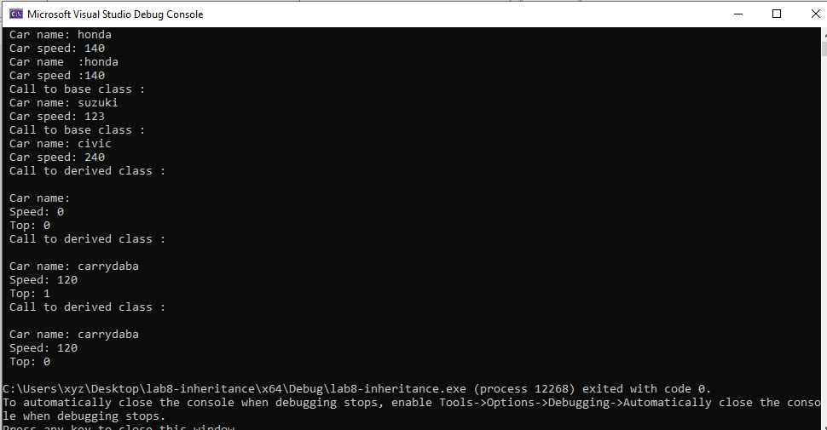

**PRACTICE TASK 2:**

**CODE:**

#include<iostream>

using namespace std;

class company

{

protected:

string c_name;

int c_id;

public:

company()

{

c_name = "";

c_id = 0;

}

company(string name, int id)

{

c_name = name;

c_id = id;

}

void set_name(string name)

{

c_name = name;

}

void set_id(int id)

{

c_id = id;

}

string get_name()

{

return c_name;

}

int get_id()

{

return c_id;

}

void display()

{

cout << " Call to base class " << endl;

cout << " Company name " << c_name << endl;

cout << " Id " << c_id << endl;

}

};

class mobile_phone :public company

{

protected:

string m_name;

int m_id;

int m_price;

public:

void set_Mname(string name)

{

m_name = name;

}

void set_Mid(int id)

{

m_id = id;

}

void set_Mprice(int pr)

{

m_price = pr;

}

string get_Mname()

{

return m_name;

}

int get_Mid()

{

return m_id;

}

int get_Mprice()

{

return m_price;

}

void show()

{

cout << " Call to derived class " << endl;

cout << " Mobile name: " << m_name << endl;

cout << " Mobile id: " << m_id << endl;

cout << " Mobile price: " << m_price << endl;

cout << " Company name: " << c_name << endl;

cout << " Company id: " << c_id << endl;

}

};

class laptop :public company

{

protected:

string l_name;

public:

void set_Lname(string name)

{

l_name = name;

}

string get_Lname()

{

return l_name;

}

void show()

{

cout << " Call to derived class " << endl;

cout << " Laptop name: " << l_name << endl;

cout << " Company name: " << c_name << endl;

cout << " Company id: " << c_id << endl;

}

};

void main()

{

mobile_phone obj1;

obj1.set_id(3344);

obj1.set_name("movers");

obj1.set_Mname("samsung");

obj1.set_Mid(1789);

obj1.set_Mprice(20000);

obj1.show();

laptop obj2;

obj2.set_id(5678);

obj2.set_name("mossam");

obj2.set_Lname("HP");

obj2.show();

}

**OUTPUT:  
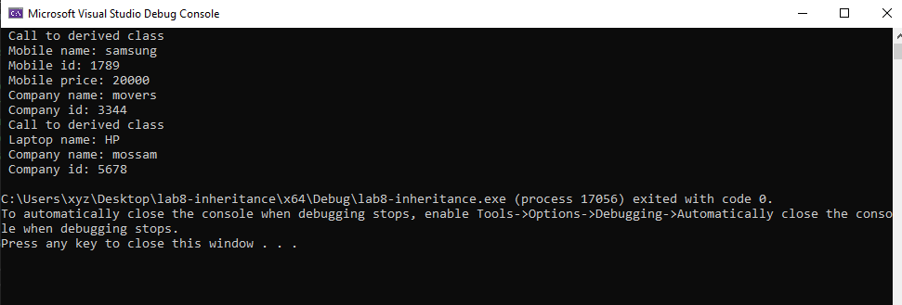**

**PRACTICE TASK 3:**

**CODE:**

class cafe_service

{

protected:

string order_id;

double price;

public:

cafe_service()

{

order_id = "ord#0";

price = 0.0;

}

cafe_service(string id, double pr)

{

order_id = id;

price = pr;

}

};

class staff_service :public cafe_service

{

protected:

double service_fee;

int cabin_num;

double total_charges;

public:

staff_service(double fee, int c_n,string id,double pr)

{

service_fee = fee;

cabin_num = c_n;

order_id = id;

price = pr;

}

double Total_charges()

{

total_charges = service_fee + price;

return total_charges;

}

void display()

{

cout << " Order id: " << order_id << endl;

cout << " Price: " << price << endl;

cout << " Service fee: " << service_fee << endl;

cout << " Cabin number: " << cabin_num << endl;

cout << " Total charges: " << total_charges << endl;

}

};

void main()

{

staff_service obj(140.0, 2, "23jk", 34.7);

obj.Total_charges();

obj.display();

} **OUTPUT:  
